**“English Comprehensive”**

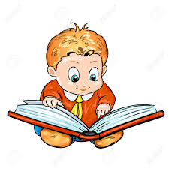

**Subject:**

**“Extensive Learning.”**

**Extensive Learning:**

**Extensive** Learning involves learners reading texts for enjoyment and to develop general reading skills. It can be compared with intensive learning, which means reading in detail with specific learning aims and tasks.

**Details:**

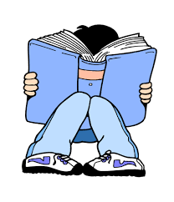 Extensive reading is reading as much as possible, for your own pleasure, at a difficulty level at which you can read smoothly and quickly without looking up words or translating to English as you go. In other words, instead of spending a half hour decoding a tiny part of one book (also known as intensive reading), you read many simpler books that are at or slightly below the level at which you read fluently. This lets you get used to reading more complex sentences with ease, reinforces the words you already know and helps you learn new words from context.

**Principles of extensive reading:**

Start with stories that are**well below**your fluent reading level, and while reading, follow these principles:

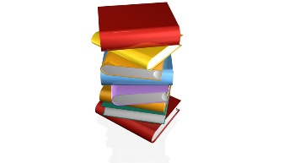

1. Don’t look up words in the dictionary.  
2. Skip over parts you don’t understand.  
3. If you aren’t enjoying one book, toss it aside and get another.

**Q-Why not use a dictionary?**

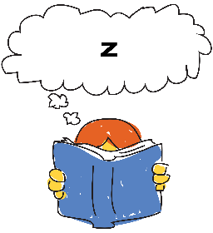Stopping to look up a word, even if it doesn’t take you very long, breaks your concentration, but if you read many basic books without a dictionary, you gain the ability to figure out words from context almost instantly and read quickly.

**Q-How do you find books at the right level?**

First, get familiar with [the classification system](http://joechip.net/extensivereading/classification-system/): once you know what your fluent reading level is, you can use it to tell almost immediately if a book is at the right level for you. A good rule of thumb is to read a page and count all of the words you don’t know. If there are more than three or four, try a simpler book.

**Q-Is it boring to read a lot of easy books?**

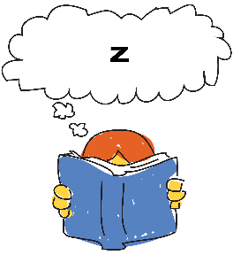No, not at all! Each book, no matter how simple it is, reinforces something you already know and teaches you something new. I hope to compile lists of particularly good books for adult readers, as well.

**References:**

[**www.google.com**](http://www.google.com)

[**www.joechip.net.com**](http://www.joechip.net.com)

**(By Liana ker from Tacoma)**